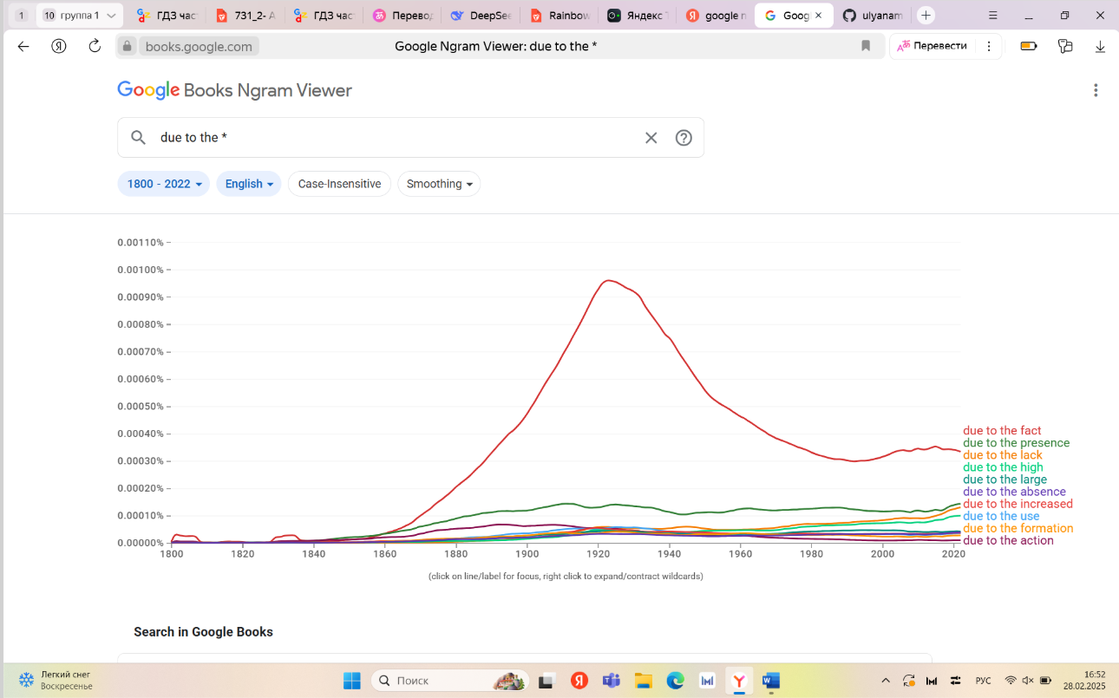

10 самых частотных фраз “due to the”:

1. Due to the fact

2. Due to the presence

3. Due to the lack

4. Due to the high

5. Due to the large

6. Due to the absence

7. Due to the increased

8. Due to the use

9. due to the formation

10. Due to the action